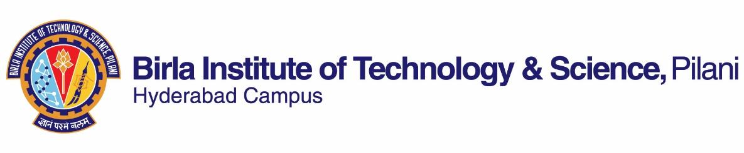

**SECOND SEMESTER 2022-23**

**Course Handout (Part II)**

Date: 16.01.2023

In addition to part -I (General Handout for all courses appended to the time table) this portion gives further specific details regarding the course.

***Course No.* : CHE F243**

***Course Title* : Materials Science and Engineering**

***Instructor-in-charge* : Dr. Debirupa Mitra**

**Scope and Objective of the Course:**

The objective of the course is to introduce the fundamentals of materials science to Chemical engineering undergraduate students. The course will impart a basic understanding of the structure and properties of different types of materials such as metals, ceramics and polymers. The course will include examples to expose students to recent developments in materials science & engineering research and applications.

**Learning Outcomes:**

On completing this course the student should be able to:

1. Understand the application of materials in various aspects of Chemical engineering
2. Classify materials, describe the basic structure of materials at the molecular, microscopic, and macroscopic scales and understand structure-property correlations.
3. Select appropriate type of material for specific application
4. Understand basic materials characterization

**Text Book:**

**T1. Callister’s Materials Science and Engineering** by William D. Callister, Jr. and David G. Rethwisch, Adapted by R. Balasubraniam, Second Edition, John Wiley (2019)

**Reference Books:**

**R1.** Material Science and Engineering by V. Raghavan, Sixth Edition, Prentice-Hall of India Private Limited (2018)

**Course Plan:**

|  |  |  |  |
| --- | --- | --- | --- |
| **Lect. No.** | **Learning Objectives** | **Topics to be covered** | **Chapter in the Text Book** |
| 1 | Introduction | Classification of Materials | Ch. 1 (T1) |
| 2 | Atomic structure and Bonding in materials | Bonding forces & Energies; Primary and Secondary bonds | Ch. 2 (T1) |
| 3-9 | Crystallography and Metallic structures | Unit cell; Crystallographic points, directions and planes; Crystal structures, Diffraction technique | Ch. 3 & 4 (T1) |
| 10-11 | Imperfections in solids | Vacancies and interstitials; dislocations and grain boundaries | Ch. 5 (T1) |
| 12-13 | Diffusion | Diffusion mechanisms | Ch. 6 (T1) |
| 14-16 | Phase diagrams | Phases; Microstructure; Phase equilibrium; Iron-Carbon system | Ch. 7 (T1) |
| 17-19 | Phase Transformations | Kinetics of transformation; Microstructure changes in Fe-C alloys | Ch. 8 (T1) |
| 20-21 | Mechanical properties of metals | Stress-Strain; Elastic and plastic deformations; Mechanical properties of Fe-C alloys. | Ch. 9 (T1) |
| 22-23 | Failure of metals | Fracture; fatigue; creep | Ch. 11 (T1) |
| 24-25 | Ceramic structures | Crystal structures of ceramics | Ch. 12 (T1) |
| 26-29 | Polymer structures | Molecular weight; Molecular configurations of polymers; and Polymer crystallinity | Ch. 13 & 14 (T1) |
| 30-32 | Composite materials | Fiber phase; Matrix phase; polymer matrix composite; interfaces and characterization | Ch. 15 (T1) |
| 33-34 | Electrical Properties of Materials | Electrical properties of metals, ceramics and polymers | Ch. 17 (T1) |
| 35 | Magnetic Properties of materials | Diamagnetism; Paramagnetism; Ferromagnetism | Ch. 18 (T1) |
| 36-37 | Thermal properties of materials | Glass Transition; Crystallization and Melting; calorimetry; thermal conductivity | Ch. 19 (T1) |
| 38 | Optical properties of materials | Light interaction with solids; applications of optical phenomena | Ch. 20 (T1) |
| 39-40 | Advanced/Functional materials | Nanomaterials; Biomaterials; Materials for energy and environment | Material to be provided |
| 41-42 | Materials selection | Selection of materials for different applications | Ch. 21 (T1) |

**6. Evaluation Scheme:**

|  |  |  |  |  |
| --- | --- | --- | --- | --- |
| **Component** | **Duration** | **Weightage** | **Date & Time** | **Nature** |
| Quiz/Class test (Min. 2) | TBA | 20% | TBA | 10% OB + 10% CB |
| Assignments (Min. 2) | TBA | 15% | TBA | OB |
| Mid-Term Exam | 90 min | 25% | 15/03 9.30 - 11.00AM | CB |
| Comprehensive Exam. | 180 min | 40% | 12/05 FN | 20% OB + 20% CB |

**Chamber Consultation Hour:** To be announced in the first class.

**Notices:** All notices related to the course will be uploaded in CMS.

**Make-up Policy:** Make-up for quiz/class test/assignment will NOT be taken. Make-up for Mid-term or Compre will be granted for genuine cases with PRIOR approval of IC.

**Academic Honesty and Integrity Policy:** Academic honesty and integrity are to be maintained by all the students throughout the semester and no type of academic dishonesty is acceptable.

**Dr. Debirupa Mitra**

**INSTRUCTOR-IN-CHARGE**